**AMBULANCE BOOKING APPICATION**

**A Project Report**

Submitted in partial fulfilment of the

Requirements for the award of the Degree of

**Bachelor of Science (Information Technology)**

**by**

**Supriya S. Karkera**

**Roll No. 5221**

**Under the esteemed guidance of**

**Mrs. A.N.S. Sarvani**

**Coordinator B.Sc.-I.T.**



**Department Of Information Technology**

**St. Andrew's College**

**(Affiliated to University of Mumbai)**

**Bandra (W)**

**MUMBAI – 400050**

**Certificate**

**St. Andrew's College of Arts, Science & Commerce**

**St. Dominic Road, Bandra (W)**

**Mumbai-400 050.**



**This is to certify that the Project Report**

**On**

**(M.A.S.: Mumbai Ambulance Services)**

**AMBULANCE BOOKING APPLICATION**

**Prepared by the following students of**

**Bachelor of Science (Information Technology)**

**Submitted as partial fulfilment for the award of the**

**B.Sc.-I.T. degree from the University of Mumbai**

**during the Academic year 2021-22**

**___________________ ______________________**

**Internal Examiner External Examiner**

**____________________ ______________________**

**Co-ordinator, B.Sc. (I.T.) Principal**

**ABSTRACT**

Pandemic which struck us was uncalled for. Facing COVID-19 pandemic and a lot of other medical issues (such as anxiety, depression, sadness, anger, etc.) as a result. When people become victim of such diseases or any kind of health-related issue, it’s hard to find availability of transport to help us with. There are many people who do not own private vehicle or got contacts for the same.

My project is a case study and I would to most extent try to bring out the basic features which will be needed by the users/general public/patients to book an ambulance at convenience. “Mumbai Ambulance Service” application will have simple yet important features which the users will find easy to use.

The web application will have online booking system of ambulance, the list of hospitals & private nursing homes. Users also get to see their history of the past bookings if any.

**ACKNOWLEDGEMENT**

Firstly, I would like to express my deepest gratitude to Prof. A.N.S. Sarvani Co-ordinator, who supported and guided on every step of the project completion with suggestions to enhance the project.

Thanking B.Sc. (I.T.) department and college for giving us the opportunity.

I would also like to thank my friends, family and mutuals who filled up the online survey that was provided for this project. It helped me have a clear picture about the problems that they faced and how I could overcome those with my project.



-------------------------

Supriya S. Karkera

Roll No.: 5221

**DECLARATION**

I hereby declare that this project entitled “Mumbai Ambulance Services” is being done by me and has not been duplicated or submitted to any other educational institution for the award of any degree by me. To the best of my knowledge, other than me, no one else has submitted this project anywhere else for any purpose.

This project dissertation is submitted as a part of the partial fulfilment of the current **TYBSc-IT/Semester-VI** curriculum.



-------------------------

Supriya S. Karkera

Roll No.: 5221

**TABLE OF CONTENTS**

**1.** **INTRODUCTION** 1

1.1. OVERVIEW 1

1.2. OBJECTIVE 1

1.3. SCOPE 1

**2.** **REQUIREMENT SPECIFICATION** 2

2.1. HARDWARE REQUIREMENTS 2

**2.1.1.** **User Requirements** 2

**2.1.2.** **Developer Requirements** 2

2.2. SOFTWARE REQUIREMENTS 2

**2.2.1.** **User Requirements** 2

**2.2.2.** **Developer Requirements** 2

2.3. NON-FUNCTIONAL REQUIREMENTS 3

**2.3.1.** **Performance** 3

**2.3.2.** **Safety** 3

**2.3.3.** **Security** 3

**3.** **SYSTEM ANALYSIS** 4

3.1. EXISTING SYSTEM 4

3.2. PROPOSED SYSTEM 6

**3.2.1.** **FEATURES of User Application** 7

**3.2.2.** **FEATURES of Driver Application** 8

3.3. REQUIREMENT ANALYSIS 8

**3.3.1.** **Survey Questionnaire** 8

**3.3.2.** **Google form link:** 9

**3.3.3.** **Survey Responses** 9

3.4. MANAGEMENT REQUIRED 14

3.5. JUSTIFICATION OF SELECTION OF TECHNOLOGY 15

**3.5.1.** **FRONTEND TECHNOLOGY** 15

*3.5.1.1.* *HTML* 15

*3.5.1.2.* *CSS* 15

*3.5.1.3.* *JAVASCRIPT* 15

*3.5.1.4.* *BOOTSTRAP* 15

**3.5.2.** **BACKEND TECHNOLOGY** 16

*3.5.2.1.* *PHP* 16

**3.5.3.** **DATABASE TECHNOLOGY** 16

*3.5.3.1.* *phpMyAdmin* 16

**4.** **SYSTEM DESIGN** 17

4.2. MODULE DIVISION 17

**4.2.1.** **User /General public/ Patient** 17

**4.2.2.** **Ambulance Driver** 18

**4.2.3.** **Booking history of User** 18

**4.2.4.** **Booking history of Driver** 19

4.3. TRANSACTIONS 20

4.4. DATA DICTIONARY 24

4.5. USE CASE DIAGRAM 28

4.6. ER DIAGRAM 31

4.7. DFD DIAGRAM 33

4.8. DESIGN DOCUMENTATION 35

**4.8.1.** **Business rules for users** 35

**4.8.2.** **Business rules for driver** 35

**4.8.3.** **Business rules for admin** 35

4.9. TEST CASES 36

5. IMPLEMENTATION AND TESTING 37

5.2. CODE 37

5.3. TESTING APPROACH 38

**5.3.1.** **Unit Testing** 38

**5.3.2.** **System Testing** 40

**5.3.3.** **Acceptance Testing** 40

**6.** **USER MANUAL** 41

6.2. USER / PATIENT / GENERAL PUBLIC 41

**6.2.1.** **New user** 41

**6.2.2.** **Registered user** 41

**6.2.3.** **User Application Screens** 42

6.3. AMBULANCE DRIVER 45

**6.3.1.** **New user** 45

**6.3.2.** **Registered user** 45

**6.3.3.** **Driver Application Screens** 46

**7.** **CONCLUSION** 48

**8.** **REFERENCE: Webliography** 49

**List of Figures**

FIGURE 1: BsideU 4

FIGURE 2: HelpNow 5

FIGURE 3: MeduLance 5

FIGURE 4: Home Page 6

FIGURE 5: Features of user application 7

FIGURE 6: Features of driver application 8

FIGURE 7.1: Pie Chart 9

FIGURE 7.2: Pie Chart 9

FIGURE 7.3: Pie Chart 10

FIGURE 7.4: Pie Chart 10

FIGURE 7.5: Pie Chart 10

FIGURE 7.6: Pie Chart 11

FIGURE 7.7: Pie Chart 11

FIGURE 7.8: Pie Chart 11

FIGURE 7.9: Bar Graph 12

FIGURE 7.10: Bar Graph 12

FIGURE 7.11: Bar Graph 12

FIGURE 7.12: Pie Chart 13

FIGURE 7.13: Pie Chart 13

FIGURE 7.14: Pie Chart 13

FIGURE 7.15: Pie Chart 14

FIGURE 7.16: Pie Chart 14

FIGURE 8.1: Module – User / Patient 17

FIGURE 8.2: Module – Ambulance driver 18

FIGURE 8.3: Module – Booking history of user 18

FIGURE 8.4: Module – Booking history of driver 19

FIGURE 9.1: User Sign up Page 20

FIGURE 9.2: Login Successful 20

FIGURE 9.3: Table – user_details 21

FIGURE 9.4: Wrong password 21

FIGURE 9.5: Passwords don’t match error message 21

FIGURE 9.6: User successfully logged in. 22

FIGURE 9.7: User enters pick up & drop location 22

FIGURE 9.8: TABLE – user_booking 22

FIGURE 9.9: TABLE – requests 23

FIGURE 9.10: Patient requests for ambulance 23

FIGURE 9.11: TABLE – user_booking_history. 23

FIGURE 10.1: Use Case Symbol 28

FIGURE 10.2: Use case – Actor 28

FIGURE 10.3: Use case – Primary and Secondary actors 29

FIGURE 10.4: Use Case System 29

FIGURE 10.5: Use Case-Association 29

FIGURE 10.6: Use Case-Include 29

FIGURE 10.7: Use Case-Extend 30

FIGURE 10.8: Use Case diagram 30

FIGURE 11.1: ER - Entity 31

FIGURE 11.2: ER - One to One relation 31

FIGURE 11.3: ER - One to Many relation 32

FIGURE 11.4: ER - Many to many relation 32

FIGURE 11.5: ER Diagram 32

FIGURE 12.1: DFD External entity 33

FIGURE 12.2: DFD Process 33

FIGURE 12.3: DFD Data Store 33

FIGURE 12.4: DFD Dataflow 33

FIGURE 12.5: DFD level 0 34

FIGURE 12.6: DFD level 1 34

FIGURE 13: Implementation Approach – Incremental Model 37

FIGURE 14.1: Unit Testing – User Login Popup 38

FIGURE 14.2: Unit Testing – Login successful 39

FIGURE 14.3: Unit Testing – User: Map integration error to predict location as soon as typed 39

FIGURE 14.4: Unit Testing – Search box 39

FIGURE 15.1: User – Home page 42

FIGURE 15.2: User – Ambulance booking procedure 42

FIGURE 15.3: User – Empanelled Hospitals 43

FIGURE 15.4: User – Private Nursing Home 43

FIGURE 15.5: User – booking history 44

FIGURE 15.6: User – Booking confirmed 44

FIGURE 16.1: Driver – login page 46

FIGURE 16.2: Driver – signup page 46

FIGURE 16.3: Driver – Home Page 47

FIGURE 16.4: Driver – History Page 47

**List of Tables**

TABLE 1: user_details 25

TABLE 2: driver_details 25

TABLE 3: requests 26

TABLE 4: hospitals 26

TABLE 5: nursing_home 27

TABLE 6: driver_booking 27

Table 7: User login test case 36

Table 8: User booking test case 36

Table 9: Driver login test case 36

# **INTRODUCTION**

## OVERVIEW

“Mumbai Ambulance Services” i.e., M.A.S, is an application where general public can easily book an ambulance, get contact numbers and address of hospital and nursing homes.

User can login at any point of time and book an ambulance. In case of emergency, an emergency toll free contact no. can be dialled which is also displayed on the first page of the application itself.

Ambulance drivers, on their side of application, will receive notification of requests for ambulance service. Users will also get a call by the ambulance driver once they have booked ambulance.

## OBJECTIVE

* User-friendly – All typed of users (either from technical background or not) should be able use the application.
* 24/7 service – Booking availability should be for 24/7.
* Reach out to hospital – Users should be able to get contact information of hospital and nursing homes easily.
  + History – User should be able to keep a track of his/her booking history.

## SCOPE

* This application is mainly for general public / patients.
* Users can login to the system, which will provide a better experience.
* Logging in helps keep track of the booking history and bills.
* User gets to know how much time will be required for the ambulance to reach at the pickup point as the google map is embedded.

# **REQUIREMENT SPECIFICATION**

## HARDWARE REQUIREMENTS

### **User Requirements**

* Smartphone / PC / Laptop / Tablet
* Minimum Intel Pentium 4 Processor for PC
* Internet connection required: WIFI, Cellular data (2BG, 3GB, 4GB).

### **Developer Requirements**

* PC / Laptop
* 2GB minimum of RAM recommended.
* Memory: Intel Pentium 4 or later
* Internet connection required.

### SOFTWARE REQUIREMENTS

### **User Requirements**

* Operating System: Window, Android
* Web Browser – Chrome / Mozilla Firefox / Internet Explorer, etc.

### **Developer Requirements**

* Notepad++ / Visual Studio Code
* Web server: XAMPP (Apache Server)
* Database: phpMyAdmin
* Navigation: Google Location Services API / Google Maps Android API

## NON-FUNCTIONAL REQUIREMENTS

### **Performance**

* Response time should be less.
* Delay should be less.
* System must be interactive.
* User should be able to get proper service that he/she requires.
* User-friendly: Application should be easy to use by any user.

### **Safety**

* System to be developed is not a critical system, therefore safety is not an issue.
* The ambulance drivers should be notified by the system regarding request from patient on time.
* The application should be reliable. The user should get minimum to no issue during the booking procedure and usage of the application.

### **Security**

* Personal information should be encrypted.
* Only the authorized person can get access to user data.
* No other user can make changes in the database or the data.
* Detailed personal information should not be taken, only the basic necessary ones like the phone no., is required to keep track in the database.

# **SYSTEM ANALYSIS**

## 3.1. EXISTING SYSTEM

* Existing system only allows the user to find information related to ambulance, such as type of ambulance.
* Existing system has more of static pages.
* Existing system does not show user’s booking history.
* Examples of Existing Systems are as follows:

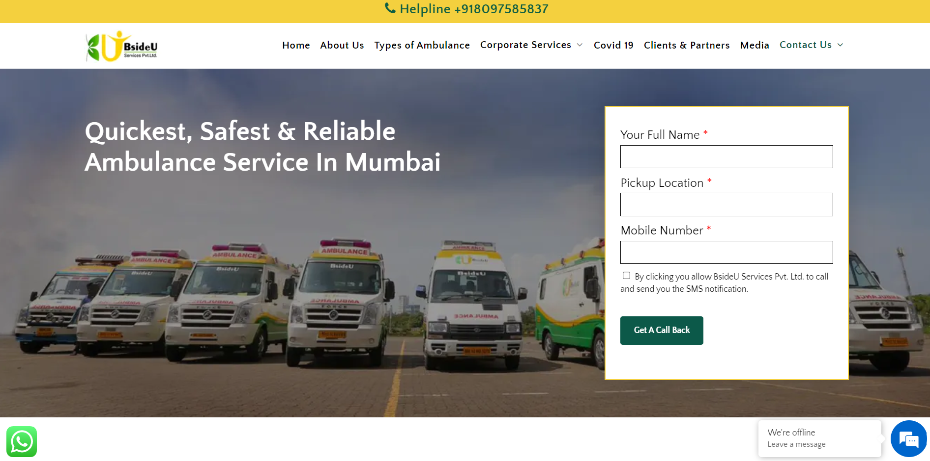

### **FIGURE 1: BsideU**

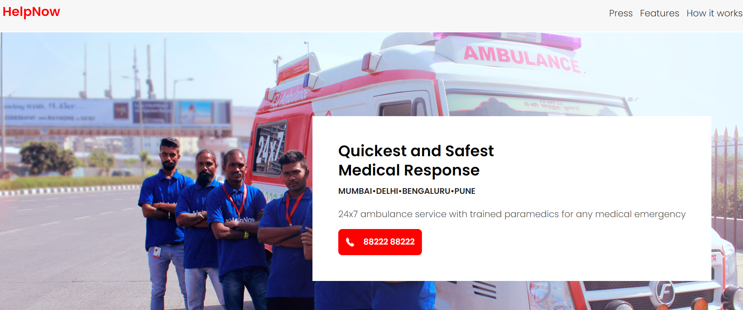

### **FIGURE 2: HelpNow**

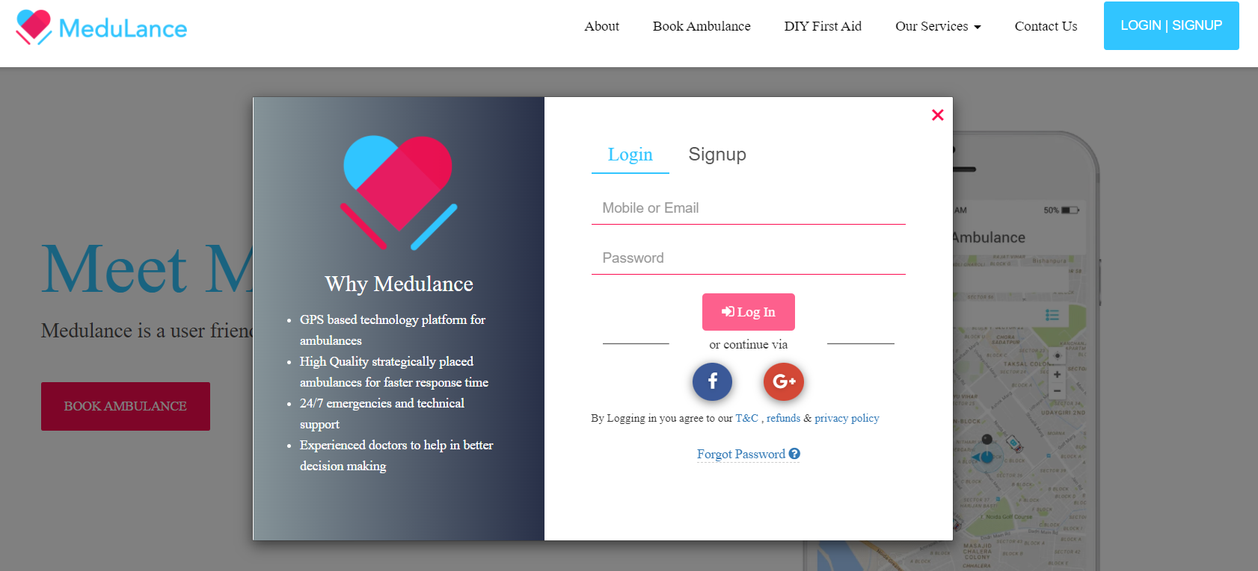

### **FIGURE 3: MeduLance**

## PROPOSED SYSTEM

**Application:** Mumbai Ambulance Services [M.A.S.].

The proposed system uses most of its features from the existing one.

Similar features of existing and proposed system are as follows:

* Application is used for booking an ambulance
* Users/ general public can cancel the booking.
* Users/ general public can contact the driver.
* Driver can contact the user.

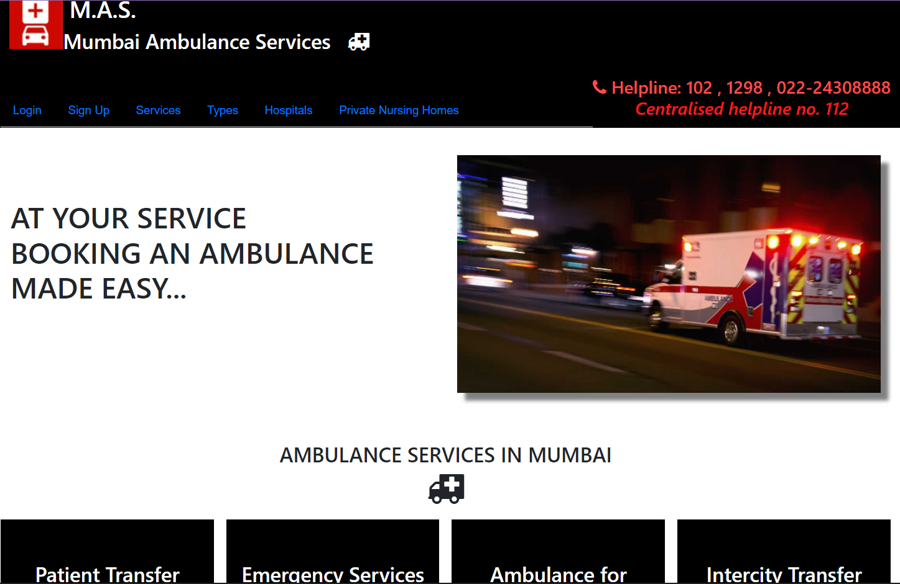

### **FIGURE 4: Home Page**

### **FEATURES of User Application**

### **FIGURE 5: Features of user application**

### **FEATURES of Driver Application**

### **FIGURE 6: Features of driver application**

## REQUIREMENT ANALYSIS

### **Survey Questionnaire**

* I had prepared few survey questions in the form of MCQ using Google Forms. The forms were sent to stakeholders via WhatsApp. Separate questionnaire was prepared for each stakeholder.
* Once the feasibility survey was complete, bar graphs and pie charts were created for the same by the Google Forms. On basis of this analysis was done.
* The responses were captured and taken in the form of Excel sheet, bar graphs and pie charts.

### **Google form link:**

<https://forms.gle/XLYB9WCNmBC6ZhiG6>

### **S****urvey Responses**

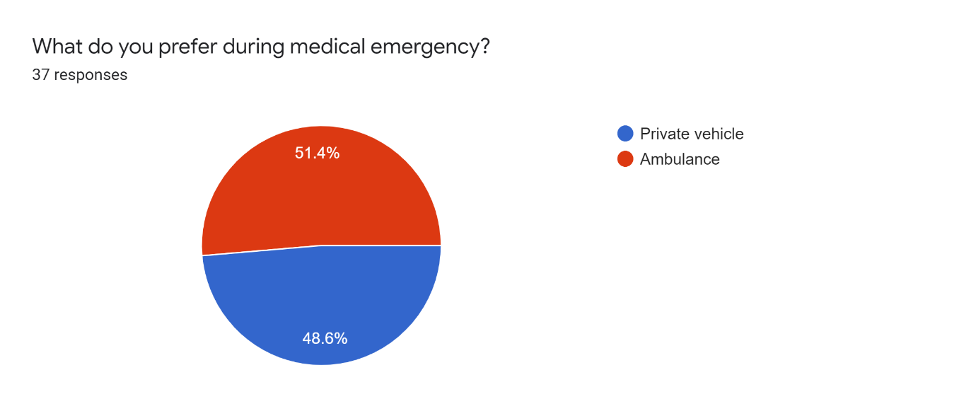

### **FIGURE 7.1: Pie Chart**

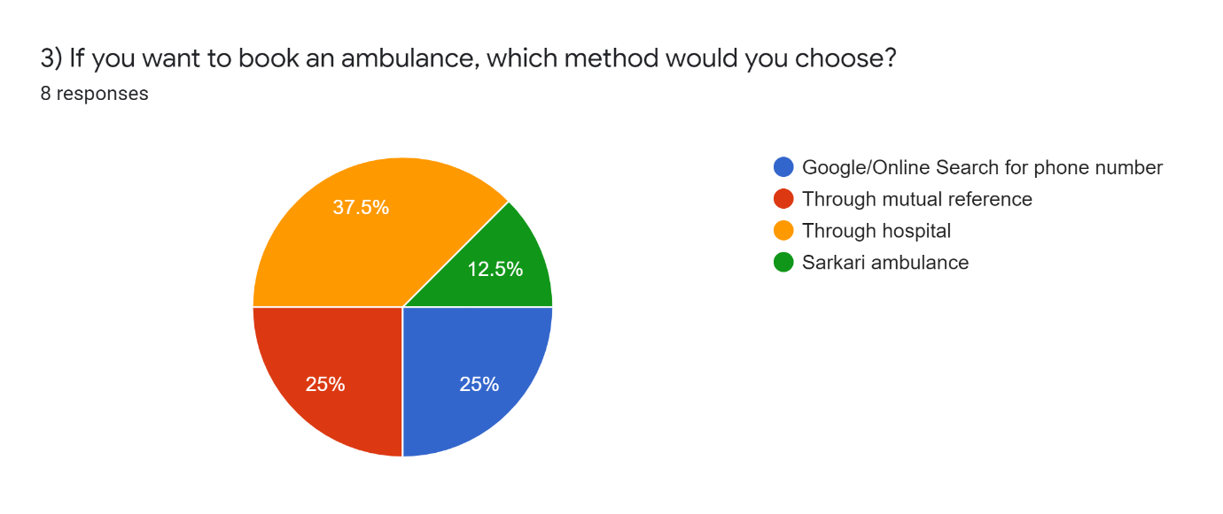

### **FIGURE 7.2: Pie Chart**

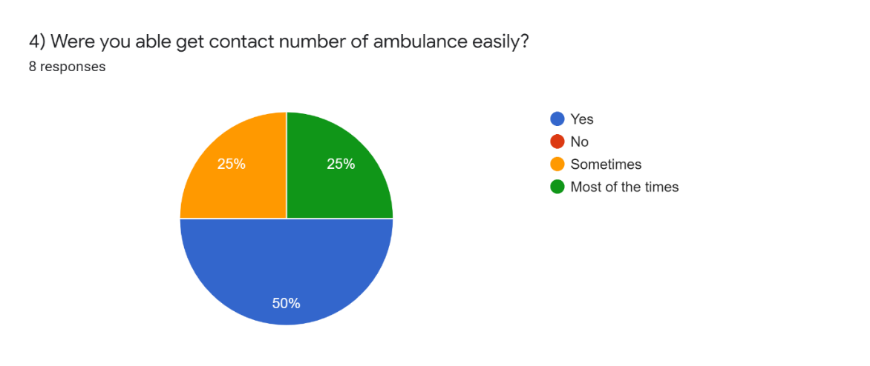

### **FIGURE 7.3: Pie Chart**

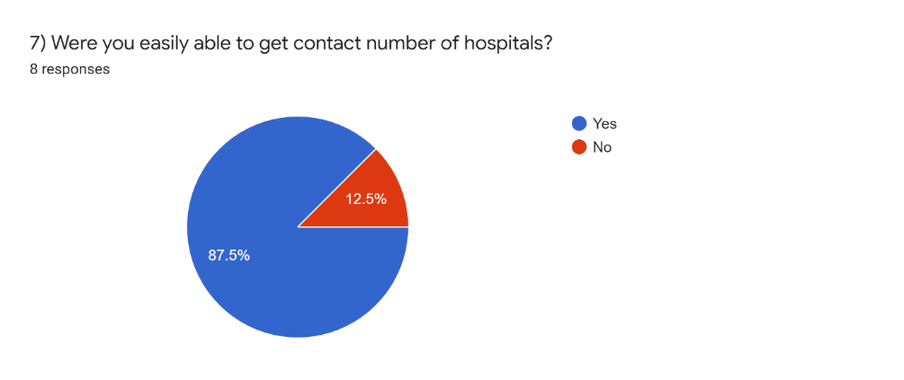

### **FIGURE 7.4: Pie Chart**

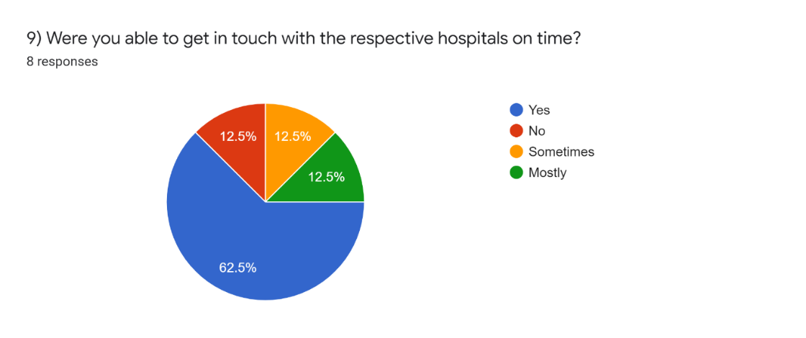

### **FIGURE 7.5: Pie Chart**

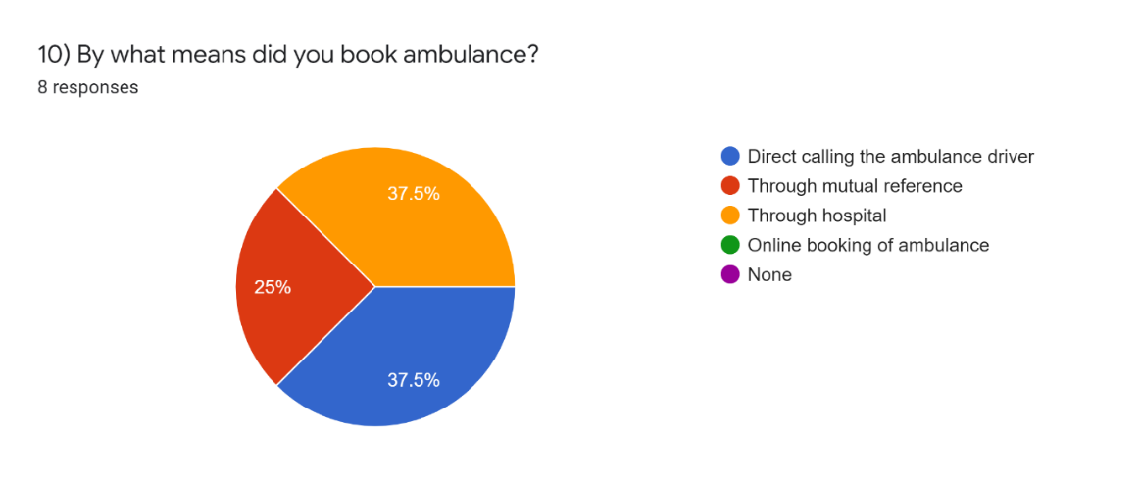

### **FIGURE 7.6: Pie Chart**

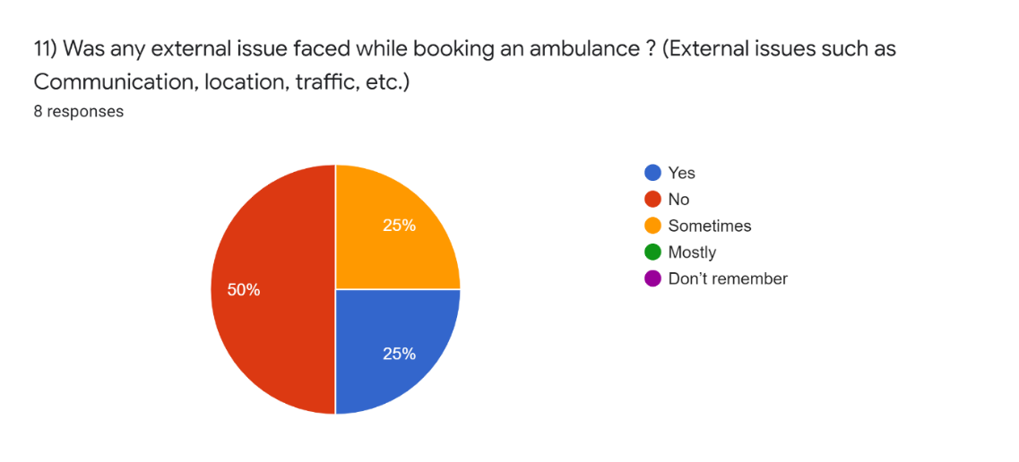

### **FIGURE 7.7: Pie Chart**

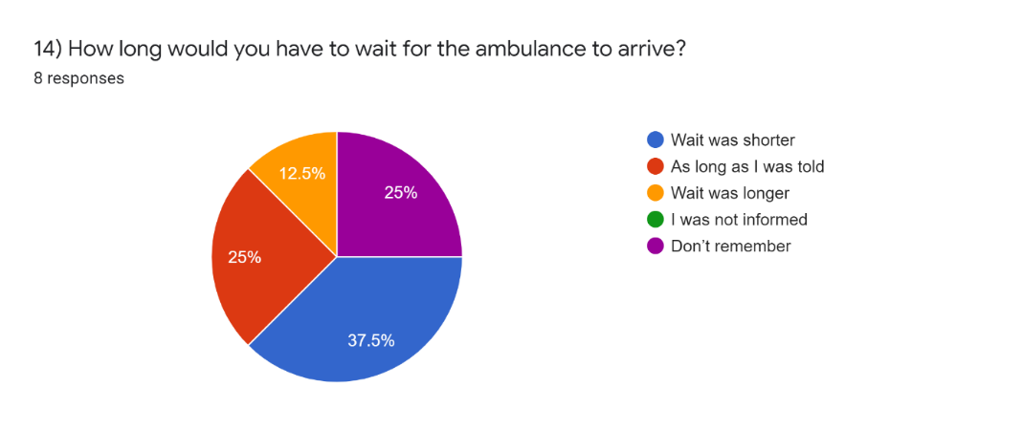

### **FIGURE 7.8: Pie Chart**

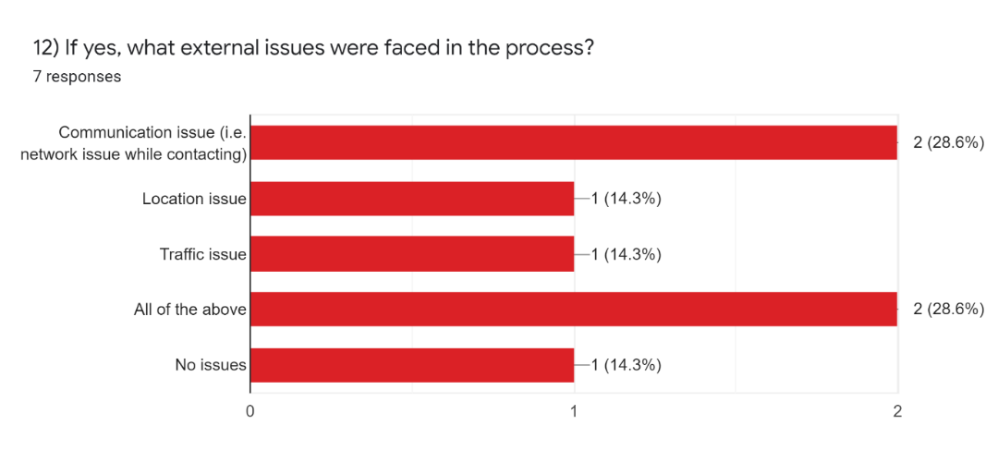

## **FIGURE 7.9: Bar Graph**

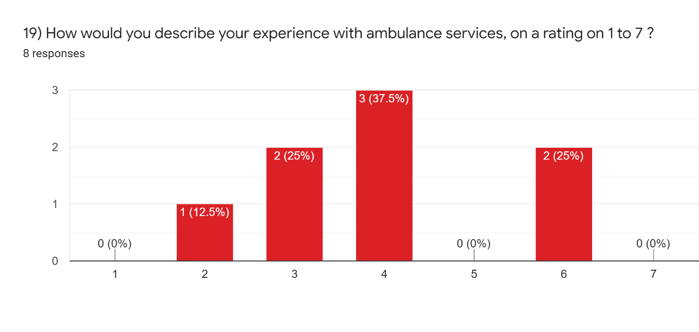

### **FIGURE 7.10: Bar Graph**

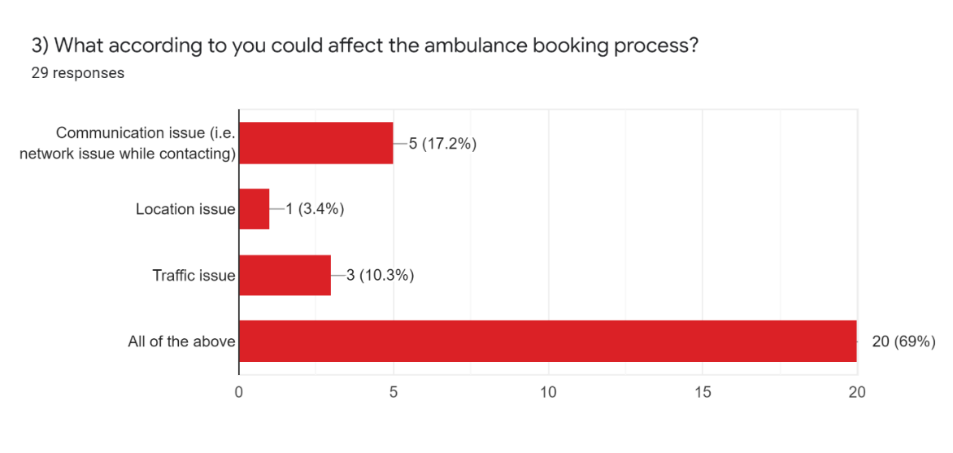

### **FIGURE 7.11: Bar Graph**

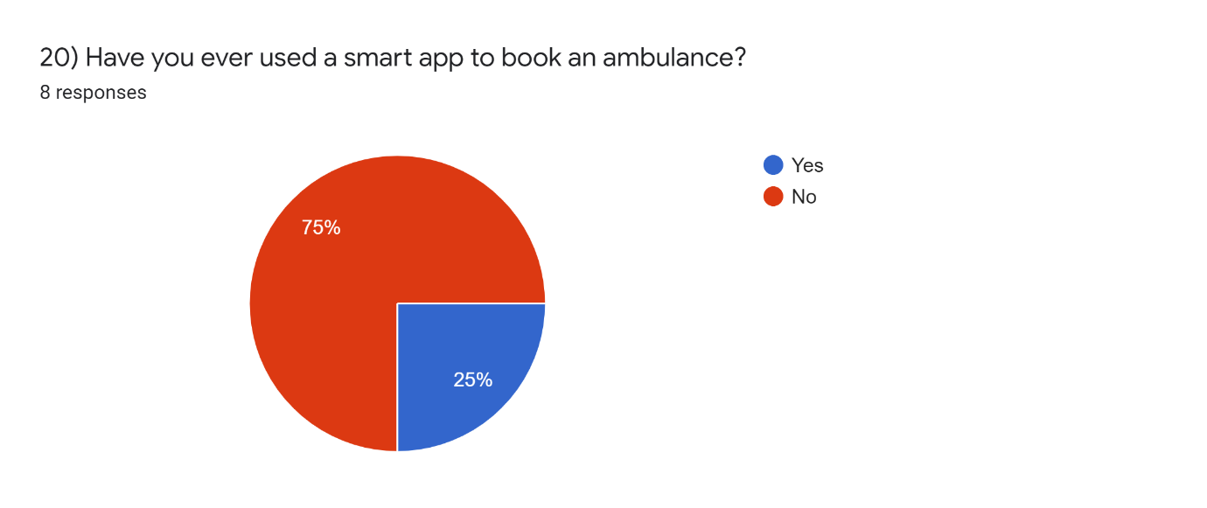

### **FIGURE 7.12: Pie Chart**

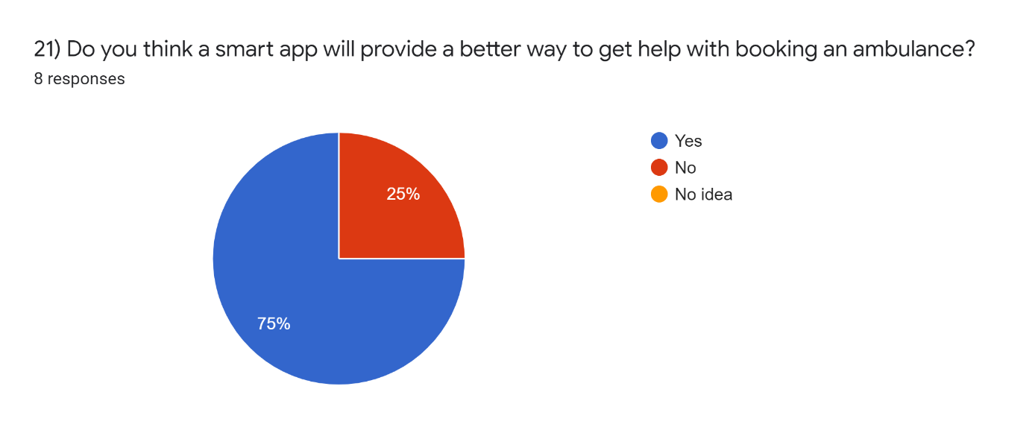

### **FIGURE 7.13: Pie Chart**

* **Response by general public who has never booked an ambulance:**

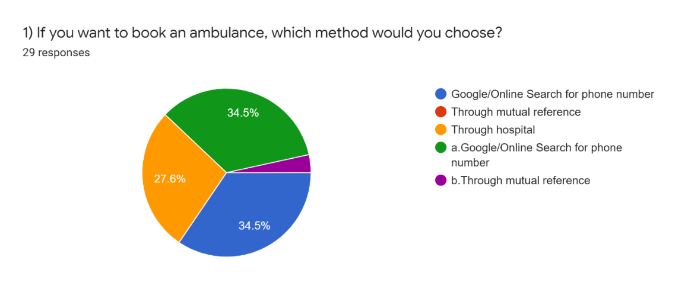

### **FIGURE 7.14: Pie Chart**

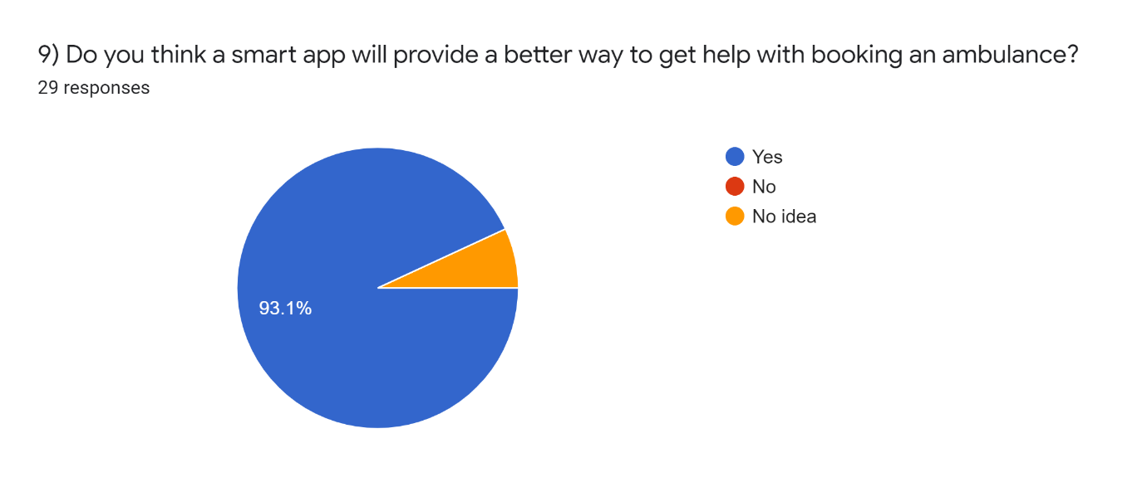

### **FIGURE 7.15: Pie Chart**

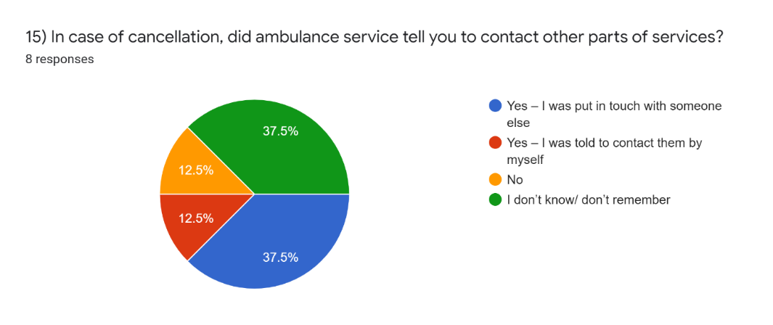

## **FIGURE 7.16: Pie Chart**

## MANAGEMENT REQUIRED

1. Location Management
2. Driver Management
3. User Management
4. Booking Management
5. Vehicle Management – Ambulance
6. Integration with Google Analytics

## JUSTIFICATION OF SELECTION OF TECHNOLOGY

### **FRONTEND TECHNOLOGY**

### *HTML*

* + HTML is free to use and is supported by all browsers.
  + HTML is the basic of all programming languages.
  + When using HTML, we do not have to purchase any extra software because by default it’s in every window.

### *CSS*

* + CSS describes how HTML elements are to be displayed on the screen or any other media.
  + CSS helps in better website speed, i.e., fast website loading.
  + CSS saves a lot of work; it can control the layout of multiple web pages all at once.
  + CSS makes it easy to specify the amount of white space between text lines, the amount of line indentation, the colors used for the text & the background, the font size and style and many more.

### *JAVASCRIPT*

* Since JavaScript is a “interpreted language”.
* JavaScript is a client-side script.
* It speeds up the execution of the program as it saves the time required to connect to the server.
* JavaScript can be embedded into any webpage.

### *BOOTSTRAP*

* Bootstrap helps in responsive structures and styles.

## **BACKEND TECHNOLOGY**

### *PHP*

* PHP is an acronym for “Hypertext Pre-processor”. PHP is a widely used open- source scripting language. PHP scripts are executed on the server side.
  + PHP is free to download and use.
  + PHP can generate dynamic page content.
  + PHP can create, open, read, write, delete and close files on server.
  + PHP can collect form data.
  + PHP can add, delete, modify data in your database.
  + PHP can be used to control user access.
  + With PHP you are not limited to the output HTML. You can output images, PDF files & even flash movies. You can also output any text such as XHTML & XML.
  + MySQL is the most popular database system used with PHP.

## **DATABASE TECHNOLOGY**

### *phpMyAdmin*

* + phpMyAdmin can run on any server or any OS as it has a web browser. For my application I am using XAMPP server.
  + We can easily create, delete and edit the database and can manage all elements using the graphical interface of phpMyAdmin, which is much easier than MySQL command line editor.

# **SYSTEM DESIGN**

## MODULE DIVISION

### **User /General public/ Patient**

* User can login to the system “Mumbai Ambulance Services”.
* New user can sign up.
* Any user (new or existing) can give direct call on toll free no.
* User can book an ambulance.
* User can view his/her booking history only if he/she is a registered user.
* User can make payment using various methods such as UPI, debit/credit card, digital wallet, cash but the payment needs to be done personally when they meet the ambulance driver.
* User can access the contact information of hospitals & Nursing homes.

## **FIGURE 8.1: Module – User / Patient**

### **Ambulance Driver**

* Driver can login to the system “Mumbai Ambulance Services (Driver)”.
* Driver has to compulsorily register himself.
* Registered driver can login to the system.
* Driver gets alerts, he has to accept the request.
* Driver also gets his ride history.

## **FIGURE 8.2: Module – Ambulance driver**

### **Booking history of User**

Booking history of users can be seen on the navigation bar of the system. It shows when the booking was made, it’s status [booked or cancelled] and the pickup and drop off location. Following is the data user booking history will contain –

### **FIGURE 8.3: Module – Booking history of use**r

### **Booking history of Driver**

Like user / general public, driver can also view his history. This option is provided to him on the navigation bar of the application itself. Below is the list of data that history of driver will include –

## **FIGURE 8.4: Module – Booking history of driver**

## TRANSACTIONS

* When user signs up successfully:

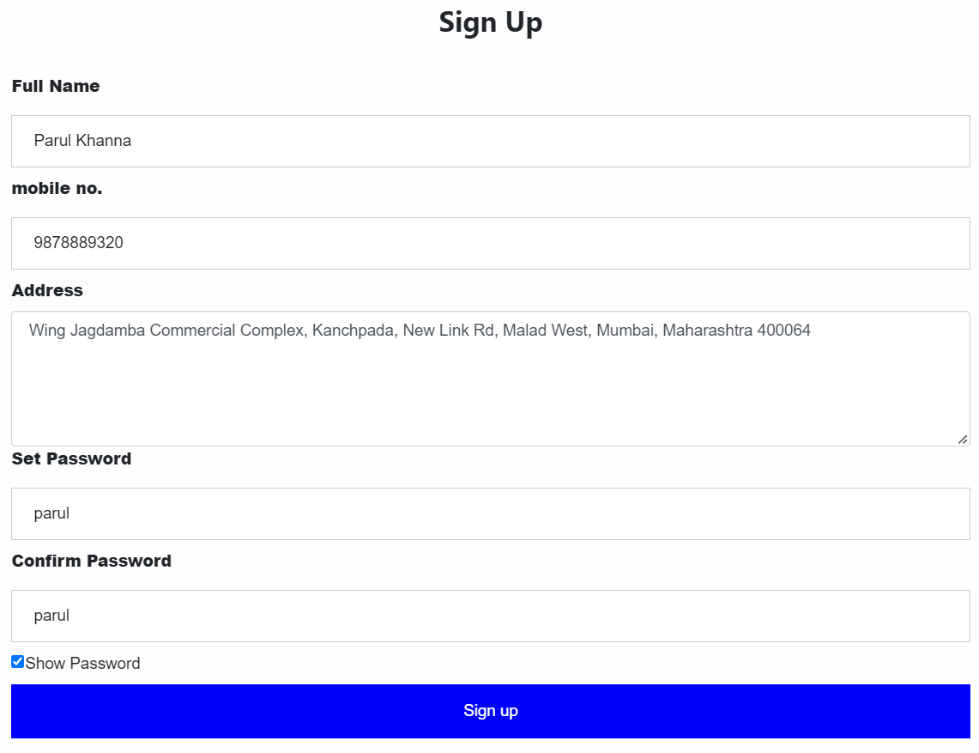

## **FIGURE 9.1: User Sign up Page**

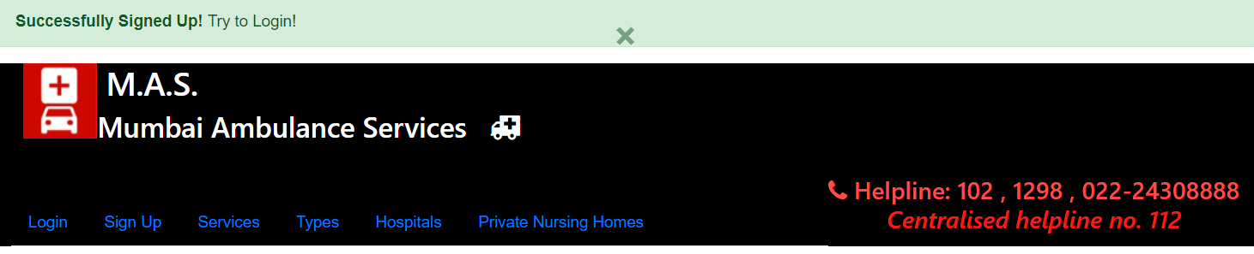

## **FIGURE 9.2: Login Successful**

User data stored into database: -

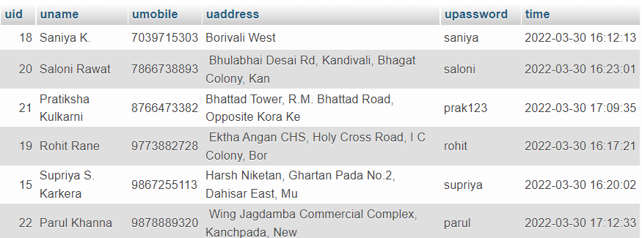

## **FIGURE 9.3: Table – user_details**

* When passwords don’t match while signing up: -

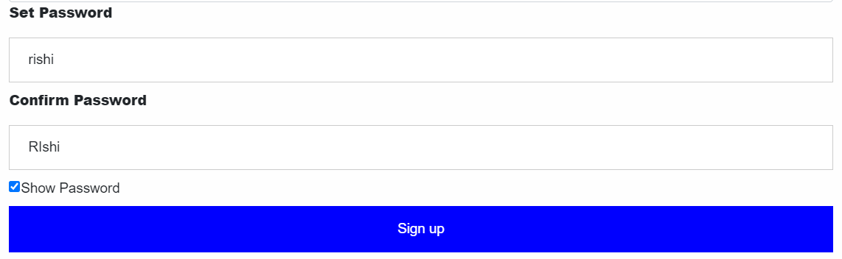

## **FIGURE 9.4: Wrong password**

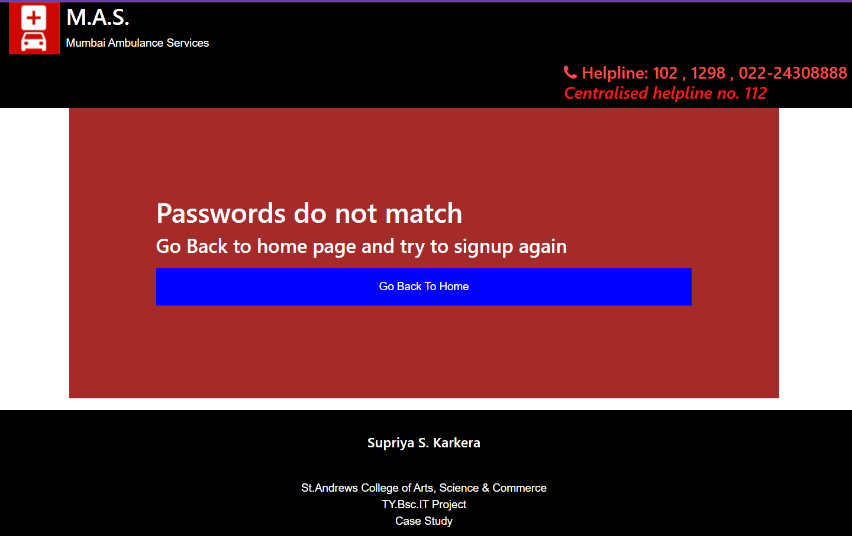

## **FIGURE 9.5: Passwords don’t match error message**

* Once the existing user successfully logs into the system, success message is shown and user is redirected to *Booking Procedure* page.

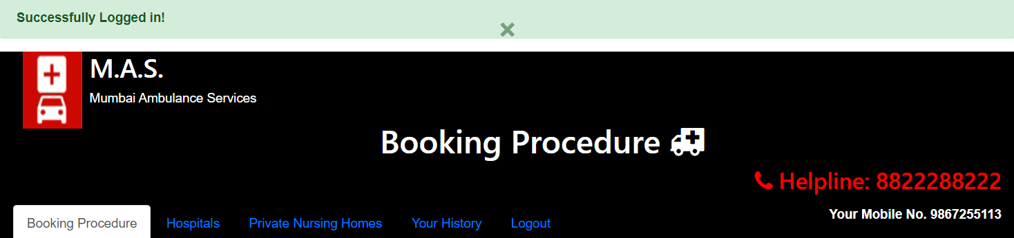

## **FIGURE 9.6: User successfully logged in.**

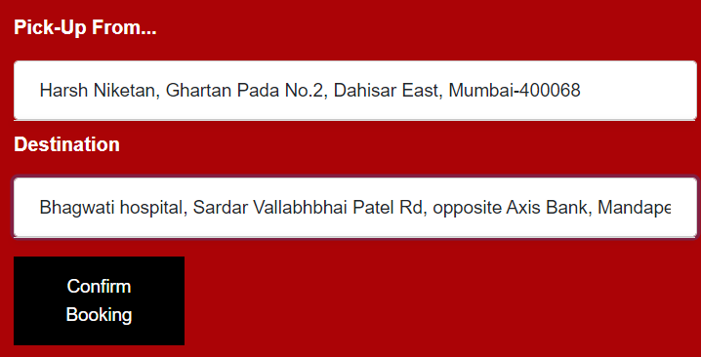

## **FIGURE 9.7: User enters pick up & drop location**

* User booking procedure: Once clicked on confirmed button, it should be recorded on the user side history and should notify the driver.



## **FIGURE 9.8: TABLE – user_booking**

* Booking also gets recorded into another table which maintains flexible data which is then sent to driver as requests.



## **FIGURE 9.9: TABLE – requests**

* The above information is fetched and displayed to driver as shown below:

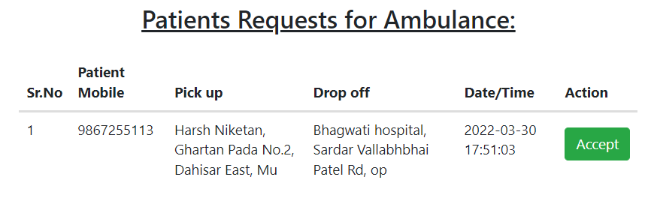

## **FIGURE 9.10: Patient requests for ambulance**

* If the user cancels booking then
  1. delete from table: *requests,*
  2. requests from driver side &
  3. show status as cancelled in user booking history



## **FIGURE 9.11: TABLE – user_booking_history.**

## DATA DICTIONARY

**Table contains:**

1. *Field name*

Field names are the column names in a table. It should have a particular datatype and size.

1. *Datatype & size*

Data types used are varchar, date, time, int, money.

1. *Constraints applied:* 
   * Primary key - It is the first key which is used to uniquely identify one and only one instance of an entity uniquely.
   * Candidate key - The remaining attributes except for primary key is considered to be a candidate key. These keys are as strong as the primary key.
   * Foreign key - These keys are the columns of the table which is used to point to the primary key of another table.
2. *Description*

This is nothing but a simple text which tells us in simple terms what that particular field is used for.

## **TABLE 1: user_details**

|  |  |  |  |  |
| --- | --- | --- | --- | --- |
| **Sr.No.** | **Field Name** | **Datatype & Size** | **Constraints applied** | **Description** |
| 1 | uid | int(11) | Index | ID for each user – Auto Increment |
| 2 | uname | varchar(50) | Candidate key | User / Patient name |
| 3 | umobile | varchar(10) | Primary key | Patient / User mobile no. |
| 4 | uaddress | varchar(50) | Candidate key | Patient / User address |
| 5 | upassword | varchar(20) | Candidate key | Password of Patient / User |
| 6 | time | timestamp | NOT NULL | On update Current_timestamp() |

## **TABLE 2: driver_details**

|  |  |  |  |  |
| --- | --- | --- | --- | --- |
| **Sr.No.** | **Field Name** | **Datatype & Size** | **Constraints applied** | **Description** |
| 1 | driver_id | int(11) | Index | Auto increment. |
| 2 | dname | varchar(50) | Candidate Key | Driver name |
| 3 | dmobile | varchar(10) | Primary Key | Mobile no. of driver on which the user/patient can contact the driver |
| 4 | dpassword | varchar(20) | Candidate key | Password set by the driver for the login purpose |
| 5 | dt | timestamp | NOT NULL | On update Current_timestamp() |

## **TABLE 3: requests**

|  |  |  |  |  |
| --- | --- | --- | --- | --- |
| **Sr.No.** | **Field Name** | **Datatype & Size** | **Constraints applied** | **Description** |
| 1 | sr_no | int(11) | Primary Key | Serial No. Auto increment. |
| 2 | pat_mobile | varchar(10) | Candidate key | Patient’s mobile no. |
| 3 | pat_pick | varchar(50) | Candidate key | Patient’s / User’s pickup location |
| 4 | pat_drop | varchar(50) | Candidate key | Patient’s / user’s dropoff location (hospital) |
| 5 | dt | timestamp | NOT NULL | On update Current_timestamp() |

## **TABLE 4: hospitals**

|  |  |  |  |  |
| --- | --- | --- | --- | --- |
| **Sr.No.** | **Field Name** | **Datatype & Size** | **Constraints applied** | **Description** |
| 1 | sr_no | int(11) | Index | Auto increment |
| 2 | hospital_name | varchar(100) | NOT NULL | Name of empanelled hospitals |
| 3 | hospital_Address | varchar(100) | NOT NULL | Location / address of respective hospitals |
| 4 | telephone1 | varchar(50) | NOT NULL | Telephone no. |
| 5 | nodal_officer | varchar(50) | NOT NULL | Name of nodal officers |
| 6 | telephone2 | varchar(50) | NOT NULL | Telephone no. |

## 

## **TABLE 5: nursing_home**

|  |  |  |  |  |
| --- | --- | --- | --- | --- |
| **Sr.No.** | **Field Name** | **Datatype & Size** | **Constraints applied** | **Description** |
| 1 | sr_no | int(11) | Index | Auto increment |
| 2 | ward | char(1) | NOT NULL | Ward category: ‘A’, ‘B’, ‘C’, ‘D’, ‘E’. |
| 3 | nursing_home_name | varchar(50) | NOT NULL | Name of the nursing home |
| 4 | address | varchar(100) | NOT NULL | Address of nursing home |
| 5 | beds | varchar(255) | NOT NULL | No. of Beds there. |
| 6 | contact | varchar(100) | NOT NULL | Contact information |

## **TABLE 6: driver_booking**

|  |  |  |  |  |
| --- | --- | --- | --- | --- |
| **Sr.No.** | **Field Name** | **Datatype & Size** | **Constraints applied** | **Description** |
| 1 | srno | int(11) | Index | Auto increment. |
| 2 | dmobile | Varchar(10) | Candidate Key | Driver mobile no. |
| 3 | pat_mobile | Varchar(10) | Candidate key | Patient / User mobile no. |
| 4 | dpickup | Varchar(100) | Candidate key | Patient / User pickup location |
| 5 | ddropoff | Varchar(100) | Candidate key | Patient / User drop off location |
| 6 | dt | Timestamp | NOT NULL | On update Current_timestamp() |

## USE CASE DIAGRAM

1. Use Case diagrams are used in the analysis phase of software development to articulate the high-level requirements of the system. The primary goals of use case diagram include:
   * Providing high-level view of what system does.
   * Identifying the users (actors) of the system.
   * Determining areas where human-computer interface is needed.
2. The basic components of use case diagram are actors, use case and association.
3. **Use case:** refers to ‘Set of Actions’. These actions are carried out by actors. It represents an action that accomplishes some sort of task within the system. Use cases are represented with oval shape.

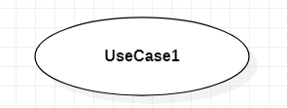

## **FIGURE 10.1: Use Case Symbol**

* **Actor:** Actor is denoted by a stick figure. It is someone/something that uses our system to achieve a goal. It could be a person, organization, another system, external device, etc. In this case, actors are the general public / patient and the ambulance driver.

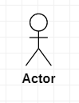

## **FIGURE 10.2: Use case – Actor**

1. Actors are mainly of 2 types: **Primary Actors and Secondary Actors**.
2. Each actor has to interact with at least one use-case in system.
3. Primary actor (here, general public / user / patient) is the one who initiates the use of system whereas secondary actor (like ambulance driver) is reactionary.

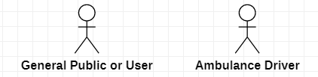

## **FIGURE 10.3: Use case – Primary and Secondary actors**

* **System:** It is something that you are developing. E.g., Website, software component, business process, application, etc. Anything within the system will be happening within our application

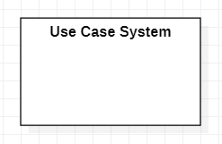

## **FIGURE 10.4: Use Case System**

* **Association:** It’s the relationship between the actor and a use-case.

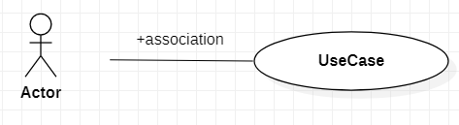

## **FIGURE 10.5: Use Case-Association**

* **Include:** Whenever the base use case is executed, the included use case is executed as well. <<include>>
  + Base use case ------------ > Include use case

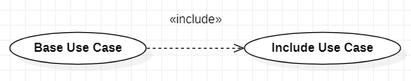

## **FIGURE 10.6: Use Case-Include**

* **Extend:** When base use case is executed, the extend use case will happen sometime but not every time. <<extend>>
  + Base use case < ----------- Extend use case

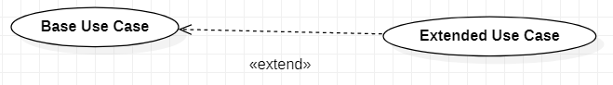

## **FIGURE 10.7: Use Case-Extend**

* **Use Case Diagram:**

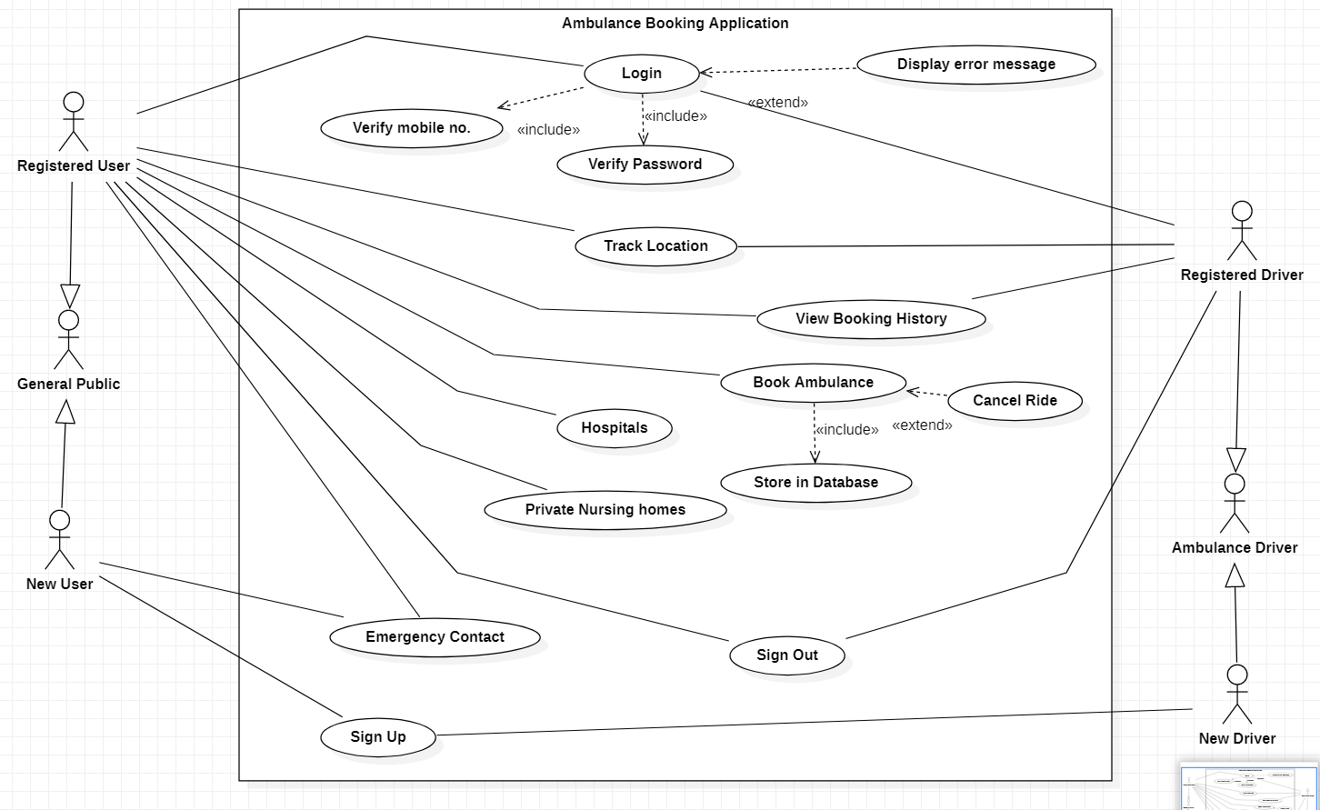

## **FIGURE 10.8: Use Case diagram**

## ER DIAGRAM

* ER diagram stands for Entity Relationship diagram. ER model is based on notation of real-world entities & their relationships, while formulating the real-world scenario into the database model, ER model creates entity set, relationship set, general attributes and constraints. ER model is best used for conceptual design of a database. ER model is based on:
  1. Entities and their attributes.
  2. Relationships among entities.
* **Components of ER Diagram:** Entity, Attributes, Relationships.
* **Entity:** person, place, thing to be entered in database. An entity in an ER Diagram is a real-world entity having properties called attributes. Every attribute is defined by its own set of values called domain.

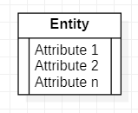

## **FIGURE 11.1: ER - Entity**

* **Relationship and ERD Cardinality:** The logical association among entities is called relationship. Relationships are mapped with entities in various ways. Mapping cardinalities define the number of associations between two entities. 
  1. One (1)
  2. Many (*)
  3. Zero or one (0...1)
  4. One or many (1...*)
  5. Zero or many (0...*)

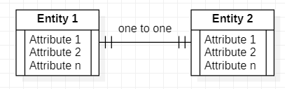

## **FIGURE 11.2: ER - One to One relation**

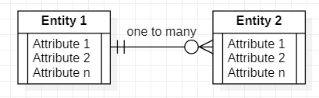

## **FIGURE 11.3: ER - One to Many relation**

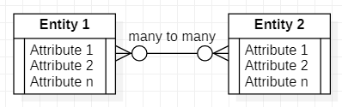

## **FIGURE 11.4: ER - Many to many relation**

* **ER Diagram:**

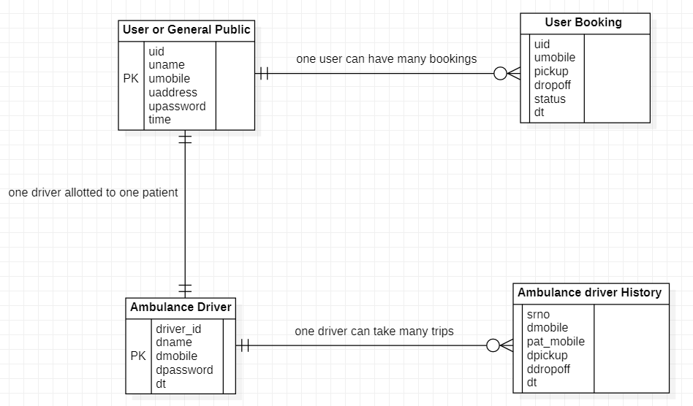

## **FIGURE 11.5: ER Diagram**

## DFD DIAGRAM

* External entity: customer, supplier, store, warehouse, company, shopping cart, staff, etc.
* Process: checking application, verify invoice, send something, create invoice, search book, purchase order, shipment, etc. ------ any action taking place.
* Data store: database, file, book information file, customer information file, stock file, business database, etc.

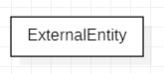

## **FIGURE 12.1: DFD External entity**

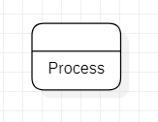

## **FIGURE 12.2: DFD Process**

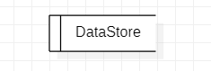

## **FIGURE 12.3: DFD Data Store**

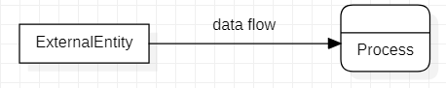

## **FIGURE 12.4: DFD Dataflow**

* **DFD Level 0 –** It is also known as context diagram. It is supposed to be an abstract view, with the mechanism represented as a single process with external parties.
* **DFD Level 1 –** It must be single process node from context diagram and is broken down into sub processes. In this level, the system must display / reveal further processing information.

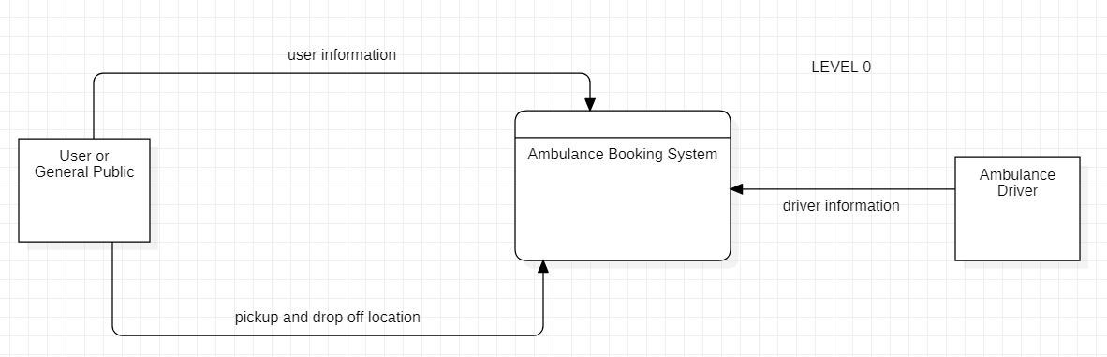

## **FIGURE 12.5: DFD level 0**

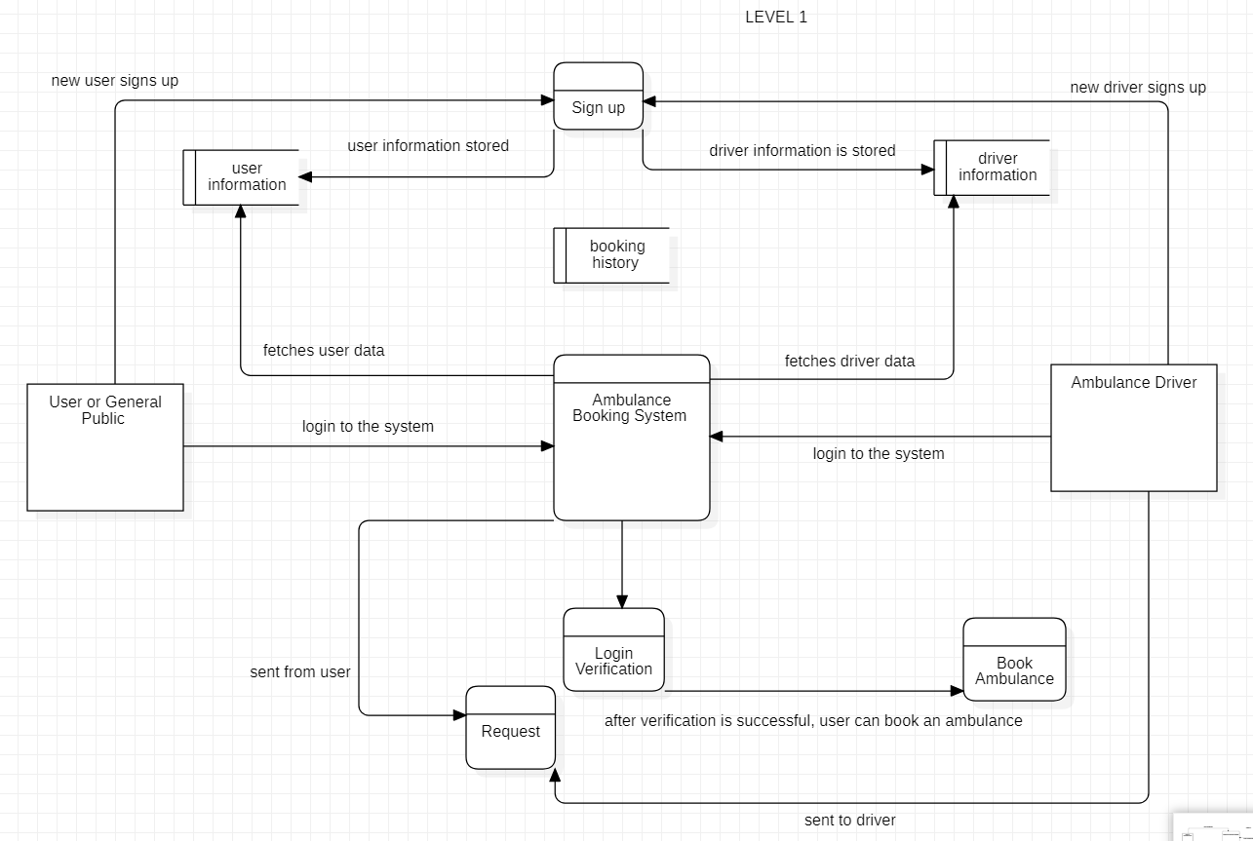

## **FIGURE 12.6: DFD level 1**

## DESIGN DOCUMENTATION

### **Business rules for users**

* User needs to register with the application to access full features.
* Payment needs to be done personally, either using cash, UPI or whatever preferable by the driver.
* User needs to click “Reached hospital” button once reached the hospital or met with driver.
* User will have to wait for driver to contact him/her for on call confirmation. Thereby the user will get the contact no. of the driver.

### **Business rules for driver**

* Driver will not get the option to decline the request of patient/user.
* Driver will only receive user’s contact no., pickup location and drop off location.
* Driver needs to remind the user to click “Reached Hospital” button. Then and only then will driver will have record in his history.

### **Business rules for admin**

* Admin needs to maintain integrity of the data entered by the user.

## TEST CASES

## **Table 7: User login test case**

|  |  |  |  |
| --- | --- | --- | --- |
| TEST CASES | Mobile no. | Password | Result |
| T1 | x |  | Don’t allow |
| T2 | x | x | Don’t allow |
| T3 |  | x | Don’t allow |
| T4 |  |  | Allow |

## **Table 8: User booking test case**

|  |  |  |  |
| --- | --- | --- | --- |
| TEST CASES | Pickup location | Dropoff Location | Result |
| T1 | x |  | Don’t proceed. |
| T2 | x | x | Don’t proceed. |
| T3 |  | x | Don’t proceed. |
| T4 |  |  | Proceed. |

## **Table 9: Driver login test case**

|  |  |  |  |
| --- | --- | --- | --- |
| TEST CASES | Mobile no. | Password | Result |
| T1 | x |  | Don’t allow |
| T2 | x | x | Don’t allow |
| T3 |  | x | Don’t allow |
| T4 |  |  | Allow |

# IMPLEMENTATION AND TESTING

## CODE

* Implementation Approach – Incremental Model
* Requirement analysis – The system is designed based upon the requirements and analysis done for the same. Feasibility survey was conducted. Needs of the system and the users were segregated.
* Design & Development – Rough GUI was designed and developed based on phase 1.
* Testing – Design was tested module wise. Testing phase checks performance of each existing function as well as additional functionality. Errors were rectified.
* Implementation – System was run to see how it works & what more changes needed to be made.

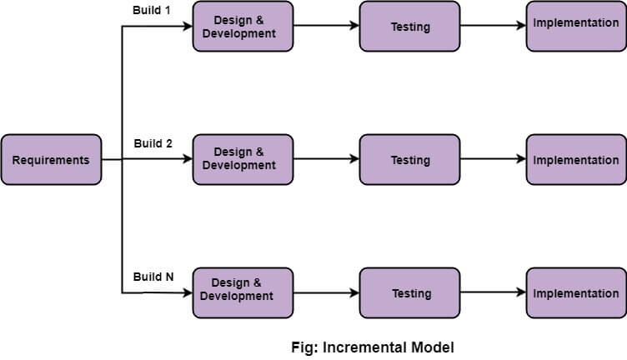

## **FIGURE 13: Implementation Approach – Incremental Model**

**WHY USING THIS APPROACH?**

* When the requirements are superior.
* A project has a lengthy development schedule.
* When Software team are not very well skilled or trained.
* When the customer demands a quick release of the product.
* You can develop prioritized requirements first.

## TESTING APPROACH

### **Unit Testing**

* Here, each module and its’s sub module is tested. Login module is tested using verification. The mobile no. and the passwords are checked if they match using conditions.
* When signing up, it is checked if the user is already an existing user or not. If not then only allow sign in else the user can either choose to login or use another phone no. to sign up.

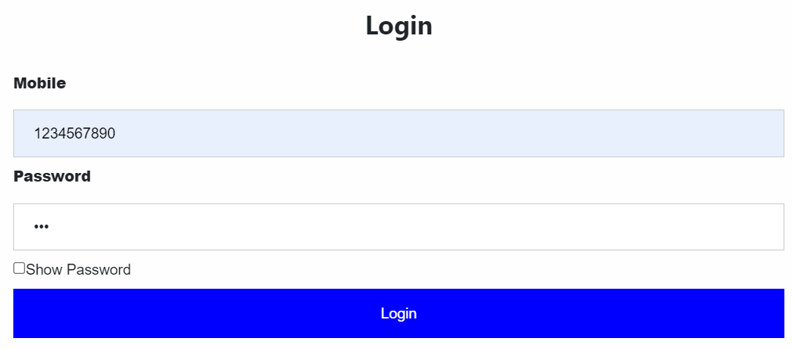

## **FIGURE 14.1: Unit Testing – User Login Popup**

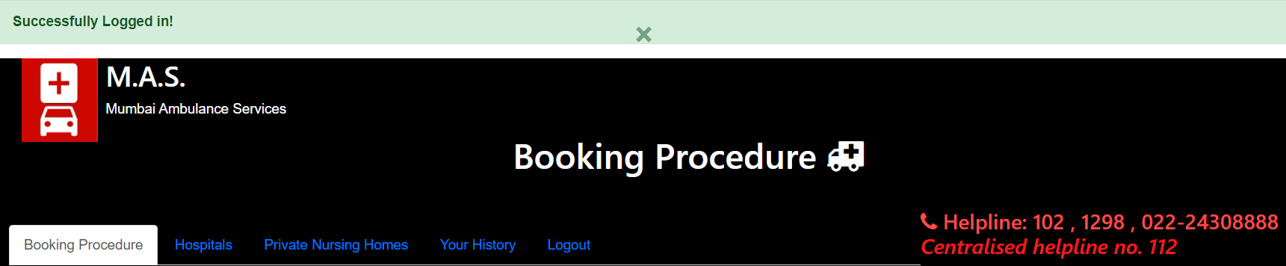

## **FIGURE 14.2: Unit Testing – Login successful**

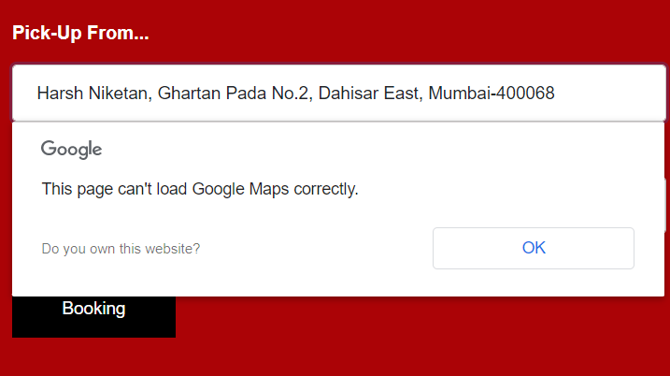

## **FIGURE 14.3: Unit Testing – User: Map integration error to predict location as soon as typed**

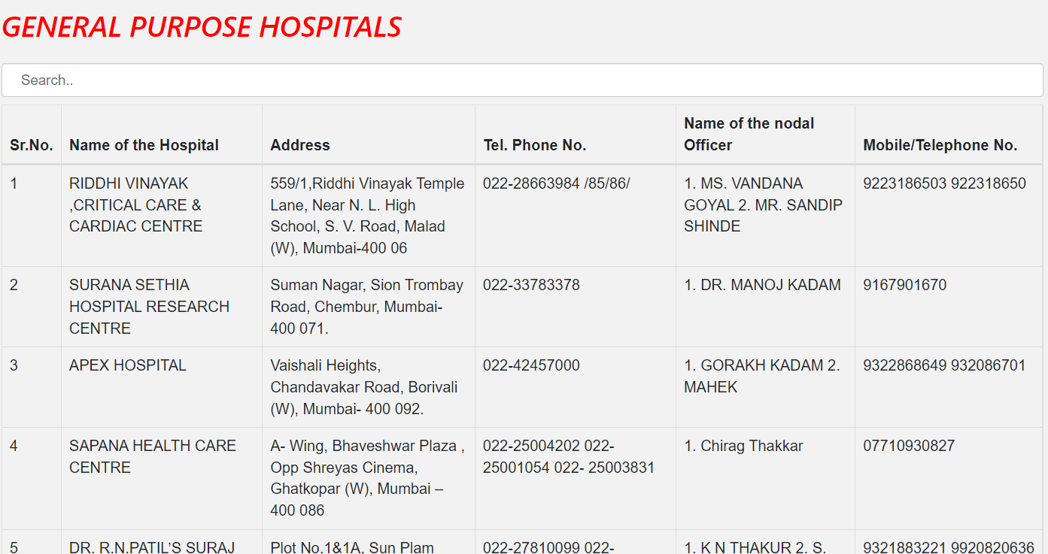

## **FIGURE 14.4: Unit Testing – Search box**

## **System Testing**

* Once the unit testing is done, they are together tested to check for the faults in the system / application itself.

* Operational Test – Application should be browser friendly, meaning the user should be able to use the application on any browser chooses and the purpose for which it is designed is to be served still.
* Functional Test – Overall functioning of the application should be checked for. Ambulance booking, history maintained.
* Security and Portability – encryption of passwords. Only authorised user to be able to login.

## **Acceptance Testing**

* White box testing – Code and design of the system is tested. Those are said to be internal structures as they are visible only to the testers.
* Black box testing – It involves testing from an external or end-user type perspective. Only the end user’s experience can be tested.

# **USER MANUAL**

## USER / PATIENT / GENERAL PUBLIC

### **New user**

1. The New user needs to first sign-up in order to book an ambulance online using the system.
2. Once signed up, the page will get refreshed and then the user can continue by logging into the system.
3. Now user is a registered user.

### **Registered user**

1. Registered user can login to the system. User can proceed with booking procedure.
2. On the booking procedure page, user will get options to –
   1. Book ambulance
   2. View hospitals
   3. View nursing homes
   4. View history
   5. Logout
3. If user wants to book ambulance, then pickup location and drop off (hospital) location is necessary.
4. Once entered the required details, user can confirm booking. User will be redirected to waiting page.
5. User will receive a call from respective ambulance driver. This will be on call confirmation.
6. User can choose to cancel booking.
7. If user wishes to choose view history option, user will get all details of the previous booking done if any.

Hospitals and Nursing homes has list of the same if required.

### **User Application Screens**



## **FIGURE 15.1: User – Home page**

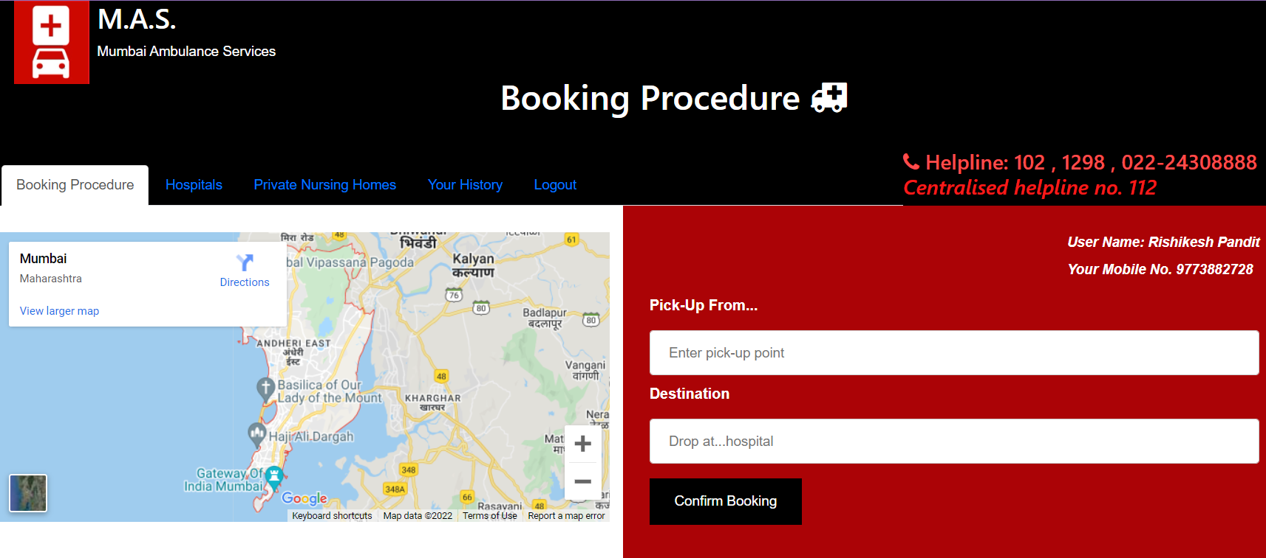

## **FIGURE 15.2: User – Ambulance booking procedure**

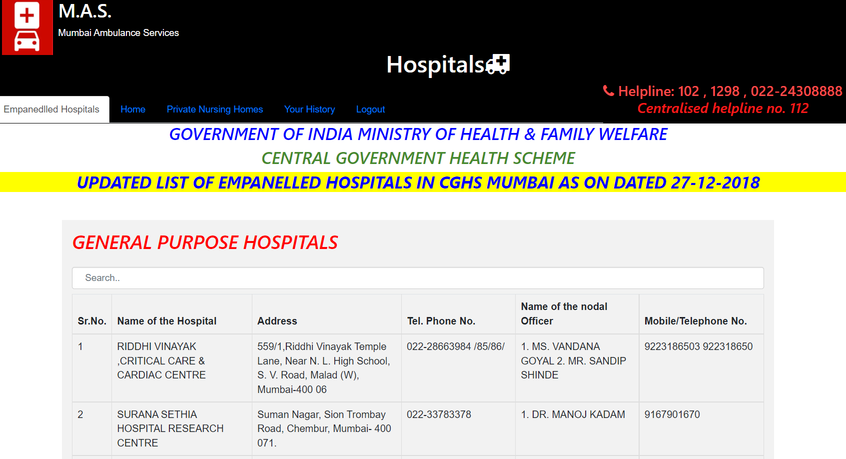

## **FIGURE 15.3: User – Empanelled Hospitals**

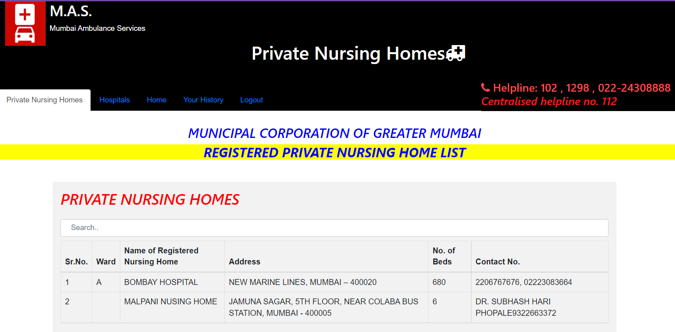

## **FIGURE 15.4: User – Private Nursing Home**

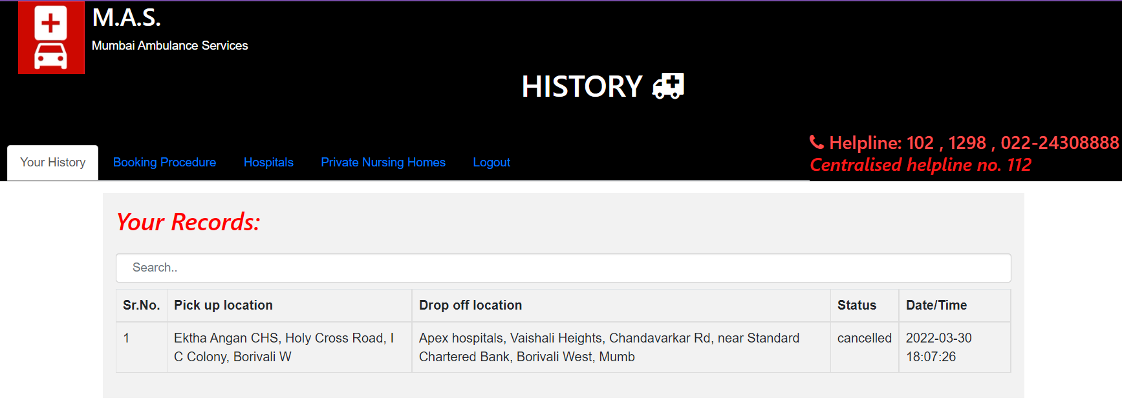

## **FIGURE 15.5: User – booking history**

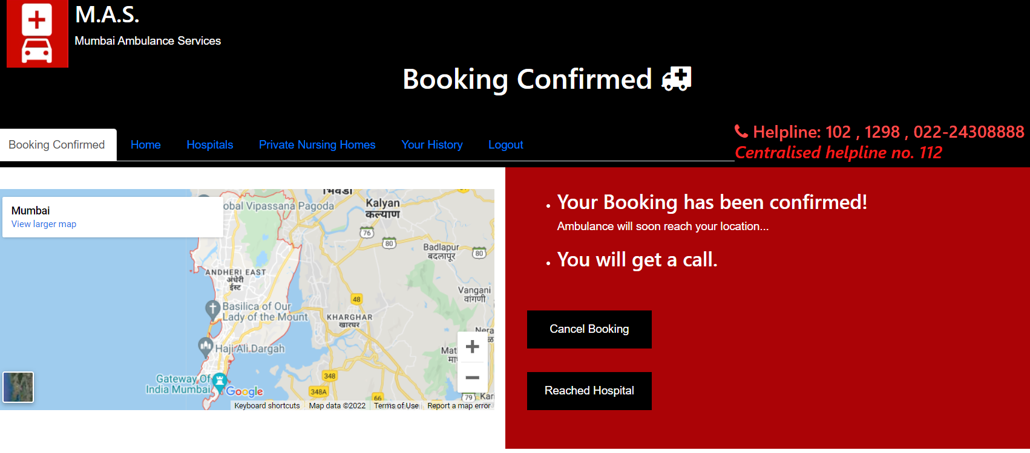

## **FIGURE 15.6: User – Booking confirmed**

## AMBULANCE DRIVER

### **New user**

1. New user needs to first register. Sign up page is the first page. Driver needs to fill in the required details and set password.
2. Once registered, the user is needs to login.
3. If driver is already registered then he can navigate to login directly.

### **Registered user**

1. Registered user needs to login.
2. Once logged in, home page will load.
3. Home page consists of
   1. Requests for ambulance
   2. Track on map
   3. View history
4. Driver gets all the patient’s required details such as mobile no., pickup location, drop off location and time of booking.
5. Driver needs to accept a particular request, give a call to that user / patient for on call confirmation.
6. Driver can track the location using google map.
7. Driver needs to as the user to press the reached hospital button so that the record for the same is visible to him in history.
8. Driver can view his history.

### **Driver Application Screens**

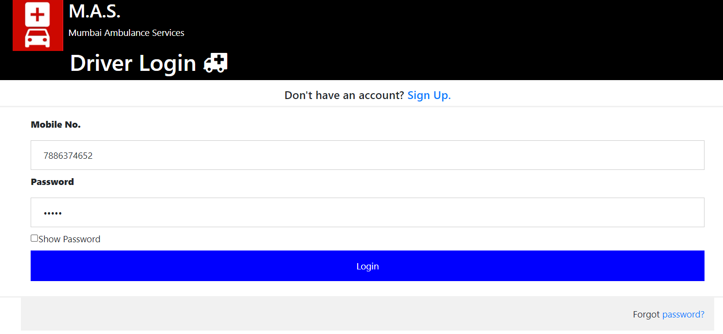

## **FIGURE 16.1: Driver – login page**

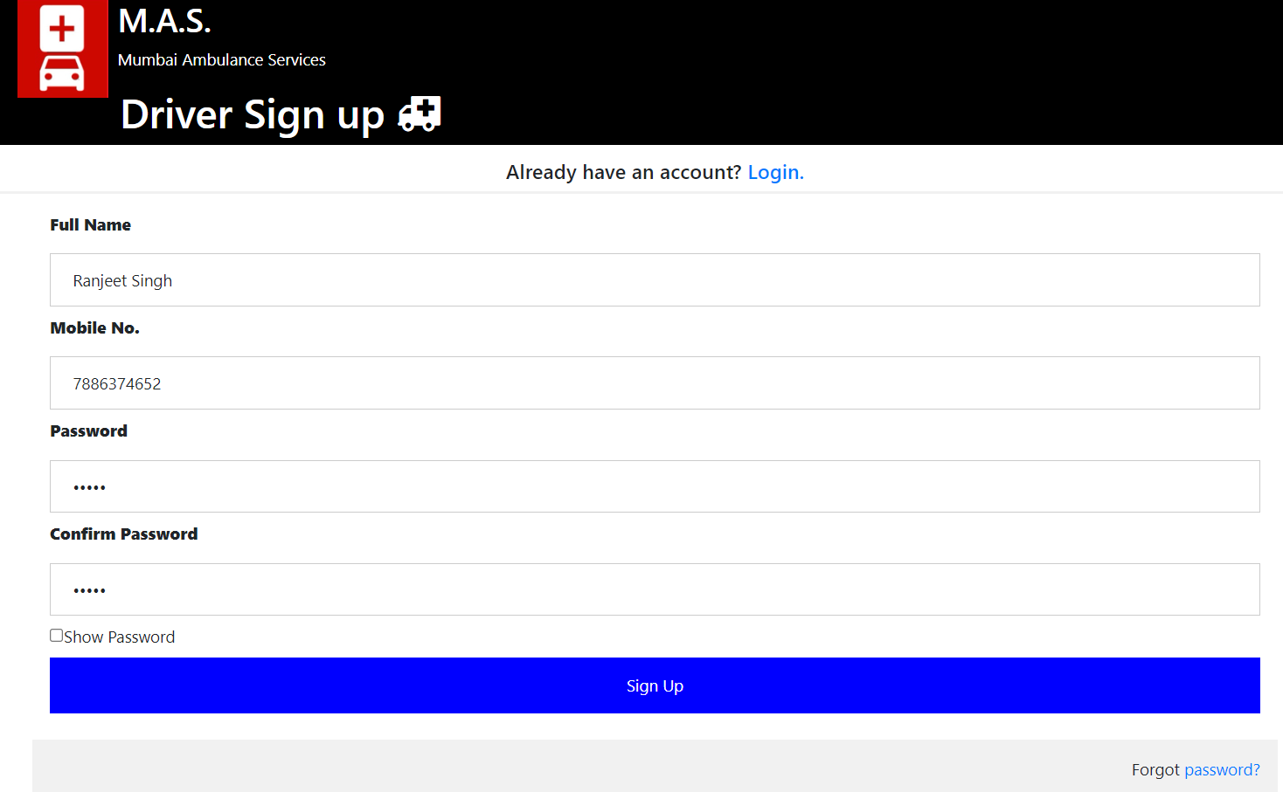

## **FIGURE 16.2: Driver – signup page**

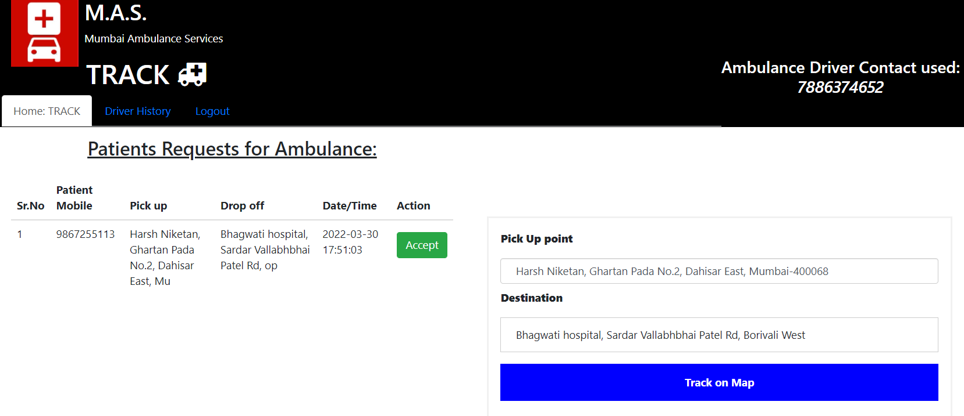

## **FIGURE 16.3: Driver – Home Page**

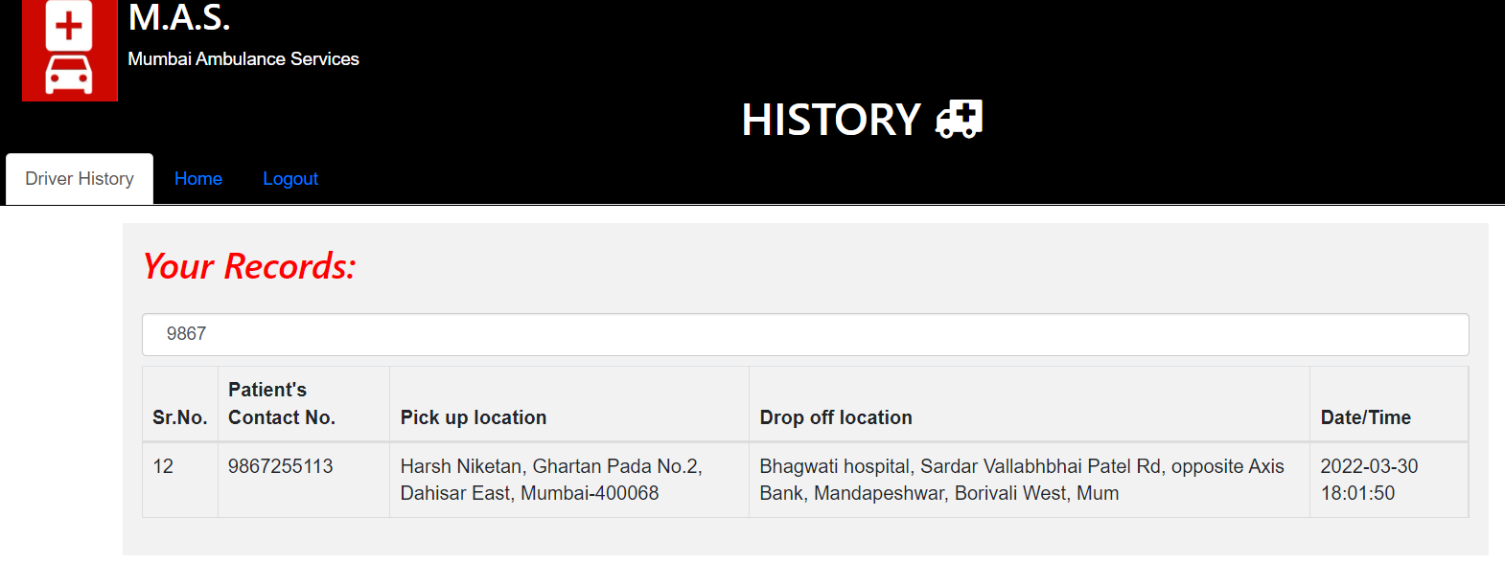

## **FIGURE 16.4: Driver – History Page**

# **CONCLUSION**

I hereby conclude by submitting this Black Book which consists of major concepts, i.e., Project management plan, requirement specification, analysis and design, implement. It also guides the user how to use the application.

**Technologies used**

* Frontend – HTML, BOOTSTRAP, CSS, JAVASCRIPT
* Backend – PHP
* Database – phpMyAdmin
* Server: XAMPP (Apache and MySQL)

# **REFERENCE: Webliography**

1. [www.stackoverflow.com](http://www.stackoverflow.com)
2. [www.w3schools.com](http://www.w3schools.com)
3. <https://www.youtube.com/watch?v=YOowArgPkQc&t=14s>
4. <https://www.youtube.com/watch?v=VXC6LbWMjuI&t=489s>
5. <https://cghsmumbai.gov.in/sites/default/files/downloads_documents/CGHS_Mumbai_Empanelled_HCO.pdf>
6. <https://nationalinsurance.nic.co.in/sites/default/files/Mumbai%20PPN%20List%20of%20Hospitals.pdf>